Drafting Direction No. 1.9
Alternative text for images in legislation
Document release 1.1
Reissued September 2021

Contents
Part 1—Preliminary 2
Introduction 2
Terminology 2
Alt text and document accessibility 2
Alt text not part of an Act etc. 2
Part 2—Requirement to include alt text for images 3
General rule 3
Special case—billable instruments 3
Special case—Commonwealth Coat of Arms 3
Part 3—Process for preparing alt text 3
Time when alt text should be prepared 3
Preparing content of alt text 3
Editorial checking of alt text 4
Part 4—Process for including alt text 4
Time when alt text is to be included 4
General 4
Urgent instruments 5
Role of drafter in including alt text 5
Special case—exposure drafts 5
Part 5—Content of alt text 6
General principles 6
Formulas 7
Complex images 8
Other images 8
Part 6—Assistance with alt text 9
Attachment A—Examples of alt text for formulas 10
Attachment B—Examples of alt text for other images 13

Part 1—Preliminary

Introduction
- This Drafting Direction deals with matters relating to the use of alternative text for images in legislation.
- This Drafting Direction applies to:
  - all legislation drafted by OPC, including Bills, parliamentary amendments, legislative instruments and notifiable instruments drafted by OPC; and
  - all images that appear in that legislation.

Terminology
- In this Drafting Direction:
  - alternative text is referred to in its abbreviated form alt text; and
  - a reference to an image is a reference to anything that will appear in legislation in image format, including MathType formulas; and
  - alt text is included in legislation when it is applied to the image using the appropriate functionality in Word.

Alt text and document accessibility
- Document accessibility is important for people with blindness or low vision. When using a computer, a person with a visual disability will often rely on screen reading software. Screen reading software cannot interpret an image for the user. Instead, it relies on a short textual description of the image known as alt text. Alt text is not visible on the face of the relevant document but, instead, sits in the properties of an image.
- The Web Content Accessibility Guidelines (WCAG) provide international standards for web accessibility. The WCAG require webpages and documents published online to include alt text for images. Commonwealth agencies are required to conform with the WCAG to a certain level. Also, the Disability Discrimination Act 1992 requires that services be accessible to people with disabilities.
- OPC maintains the Federal Register of Legislation, on which the legislation drafted by OPC is published. Also, exposure drafts of legislation drafted by OPC are often published on websites of Commonwealth agencies. Including alt text for any images in legislation drafted by OPC will help to make legislation more accessible for those users who rely on screen reading software.

Alt text not part of an Act etc.
- Under subsection 13(3) of the Acts Interpretation Act 1901, alt text is not part of an Act, or a compilation of an Act. This is also the case for legislative instruments and notifiable instruments (via the operation of section 13 of the Legislation Act 2003).
- Paragraph 15V(5)(c) of the Legislation Act 2003 provides that, in preparing a compilation of an Act, legislative instrument or notifiable instrument, First Parliamentary Counsel may include, omit or change alt text.
- As alt text is not part of an Act, neither policy authority nor Ministerial text approval is required to include alt text, and alt text can be changed and updated as appropriate.

Part 2—Requirement to include alt text for images

General rule
- Alt text is to be included in all primary and delegated legislation drafted by OPC that contains images. It is to be included for every image that is to appear in the legislation.
Note: Alt text is not required for tables that are included in legislation because tables do not appear in legislation in image format.

Special case—billable instruments
- If an image is to appear in an instrument that OPC is drafting on a billable basis, alt text should be included in the legislation by the drafter only after obtaining the agreement of the instructors. If the instructors do not agree to alt text being included by OPC, the instructors will need to make other arrangements for appropriate alt text to be prepared and included in the legislation.

Special case—Commonwealth Coat of Arms
- The image of the Commonwealth Coat of Arms appears in certain legislation drafted by OPC. The alt text for this image is automatically included as part of OPC’s templates.

Part 3—Process for preparing alt text

Time when alt text should be prepared
- Alt text for an image that is to appear in legislation that OPC is drafting should generally be prepared by the drafter at the same time as the legislation is being drafted.
- This applies to the alt text for an image that is to appear in a parliamentary amendment even though, at the time of drafting, it will not be known whether or not the parliamentary amendment will be agreed to by Parliament.

Preparing content of alt text
- If an image is to appear in legislation that OPC is drafting, the drafter should inform the instructors of the requirement to include alt text for the image. The drafter should include a drafting note under each image in the legislation along the following lines (which can be inserted using Alt + I):
[: It is OPC policy that alternative text (or alt text for short) should be included for images in legislation so the content of the images is accessible to anyone who relies on screen reading software to read the legislation.
Under subsection 13(3) of the Acts Interpretation Act 1901, alt text is not part of an Act, or a compilation of an Act. This is also the case for legislative instruments and notifiable instruments (via the operation of section 13 of the Legislation Act 2003).
We have prepared proposed alt text for you to consider (see below). Please let us know if you are happy with the proposed alt text.
Proposed alt text:]
- If the content of the image is such that the drafter does not consider it appropriate to propose alt text to the instructors, the drafter may ask the instructors to provide further instructions to assist the drafter to develop alt text for the image.
- The drafter should provide the instructors with an opportunity to comment on the alt text, and should confirm that the instructors agree that the alt text is accurate.

Editorial checking of alt text
- Once the drafter has reached a settled position with the instructors regarding the content of the alt text, the drafter should have the content of the alt text editorially checked.

Part 4—Process for including alt text

Time when alt text is to be included

General
- The following table sets out the time when alt text for an image is to be included in legislation drafted by OPC.

Time when alt text is to be included
Item | For an image that appears in… | alt text is to be included…
1 | a principal or amending Bill | when the Bill is published on the Federal Register of Legislation following introduction.
2 | a parliamentary amendment of a Bill | if the Bill, as passed by both Houses of Parliament, incorporates the parliamentary amendment—when the Bill is published on the Federal Register of Legislation as an Act following Royal Assent.
3 | an instrument | before a finalised version of the instrument is prepared (but see also paragraph 20).
Note 1: Alt text that is to be included at the time of publication on the Federal Register of Legislation will be included by Publications.
Note 2: Alt text will be included in historical as made legislation, and existing compilations of legislation, on the Federal Register of Legislation by Publications.
Note 3: If an exposure draft of legislation is required, see paragraphs 22 to 24.

Urgent instruments
- If there is insufficient time to include alt text before a finalised version of an instrument is prepared (for example, because the instrument is required urgently), the alt text may be included at a later time with the agreement of First Parliamentary Counsel.

Role of drafter in including alt text
- The following table sets out the steps a drafter should take to ensure that alt text for an image is included in legislation at the required time. These steps should be taken only after the alt text has been editorial checked as mentioned in paragraph 18.

Role of drafter in including alt text
Item | For an image that appears in… | the drafter should…
1 | a principal or amending Bill | email the alt text to lodge@legislation.gov.au
2 | a parliamentary amendment of a Bill | email the alt text to lodge@legislation.gov.au
3 | an instrument | (a) if the agreement of First Parliamentary Counsel has been obtained to include the alt text for an image after the instrument is finalised—email the alt text to lodge@legislation.gov.au; or  (b) otherwise:  (i) apply the alt text to the image in accordance with Word Note 4.2 (or contact Publications for assistance with this); and  (ii) if the image is a MathType formula—email the alt text to lodge@legislation.gov.au (because Publications may need to reapply the alt text when the instrument is published on the Federal Register of Legislation)
Note 1: Alt text must not be included in a finalised Bill or parliamentary amendment.
Note 2: If an exposure draft of legislation is required, see paragraphs 22 to 24.

Special case—exposure drafts
- Before including alt text for an image in a public or limited circulation exposure draft of legislation, the drafter should confirm with the instructors that there are no technical reasons (for example relating to the website on which the exposure draft will be uploaded) why the alt text should not be included.
- If alt text is to be included in an exposure draft of legislation:
  - the alt text is to be included before the exposure draft version is created; and
  - the drafter should apply the alt text to the image in accordance with Word Note 4.2 (or contact Publications for assistance with this); and
  - if the exposure draft is of a Bill or parliamentary amendment—the drafter should ensure that any alt text included is subsequently removed before the Bill or parliamentary amendment is finalised for printing.
- If alt text is not included in an exposure draft version of legislation, or if alt text is included in an exposure draft of a Bill or parliamentary amendment and then removed in accordance with paragraph 23(c), the requirements set out in paragraphs 19 to 21 apply to the legislation as if an exposure draft had not been required.

Part 5—Content of alt text
- The alt text that is prepared for an image should describe the content of the image. When preparing the alt text, regard should be had to the principles outlined in this Part.

General principles
The alt text should take account of the purpose and context of the image
- The purpose and context of an image will affect how the image should be described. For example, if the purpose of an image is to prescribe what a warning sign must look like, the alt text should describe what the warning sign looks like rather than merely stating that it is a “warning sign”.
- To describe what an image looks like it may be necessary to describe, for example, the shape of the image, the layout of the image and any colours used in the image (see Examples 4 and 5 in Attachment B).
The alt text should be relatively short, ideally no more than 125 characters including spaces
- This maximises compatibility with different screen reading software. However, the length of the alt text will be a matter of judgement and longer descriptions might be required in particular cases (see Examples 3 and 4 in Attachment A).
- For complex images, including complex formulas, that would otherwise require particularly lengthy alt text, it may be appropriate for the alt text to take the form of a high-level description (see paragraphs 34 and 36(c), Example 1 in Attachment A and Examples 2 and 3 in Attachment B).
The alt text should not include anything that is not in the image or that cannot be ascertained from the image
- The alt text should not provide more information about an image than a sighted reader could ascertain from the image itself. For example, if the image includes words, the alt text should not put the words in quotation marks unless the words in the image are in quotation marks. Also, if the image is a graph or chart that represents certain amounts but the amounts cannot be definitively ascertained from the graph or chart, the alt text should not state the amounts (see Example 3 in Attachment B).
A full stop is not required at the end of alt text
- It is not necessary to add a full stop at the end of alt text (see the examples in Attachments A and B).
There is no one right or perfect way to write alt text
- The content guidelines included in this Drafting Direction are designed to promote consistency in developing alt text, however, there may be cases where it is not possible or appropriate to strictly follow the principles. In such cases, the overriding principle should be that having some alt text for an image is better than having none.

Formulas
- Alt text is required for MathType formulas because these appear in legislation in image format. Care should be taken to ensure that the formula is accurately represented in the alt text (for example, the order of operations is made clear). The following table sets out standard wording (or symbols) that should be used when preparing alt text for formulas.

Standard wording etc. to be used in alt text for formulas
Item | Component of formula | Standard wording etc.
1 | start and end of formula | start formula, end formula
2 | start and end of fraction | start fraction, end fraction
3 | move from numerator to denominator in a fraction | over
4 | dividing 2 elements (other than via a fraction) | divided by
5 | adding 2 elements (e.g. A + B) | plus
6 | multiplying 2 elements (e.g. A x B, or AB where A and B are separate variables) | times
7 | subtracting 2 elements (eg. A - B) | minus
8 | equals sign (“=”) | equals
9 | subscript (e.g. A₂) | subscript
10 | superscript (e.g. A²) | superscript
11 | elements that appear in brackets | (a) if only one kind of bracket is used—open bracket, close bracket;  (b) if more than one kind of bracket is used—describe each kind of bracket (e.g. open round/square bracket, close round/square bracket)
12 | dollar sign (“$”) | Use symbol (“$”)
13 | asterisk (“*”) | Use symbol (“*”)
14 | percent sign (“%”) | Use symbol (“%”)
- For complex formulas, instead of describing each component of the formula, it may be appropriate for the alt text to state what the formula is for (see Example 1 in Attachment A). Whether or not it is appropriate to include such a high-level description will depend on the particular formula, but the following are examples of some circumstances in which a high-level description may be appropriate:
  - describing each component of the formula would result in particularly lengthy or complicated alt text;
  - the formula is not the only source of the information it contains;
  - information about the content of the formula is available in an accessible form on the relevant Department’s website.

Complex images
- An image is considered complex if the content of the image would require particularly lengthy or complicated alt text, or would otherwise be difficult to describe accurately. Examples include maps, flowcharts and diagrams.
- The following principles should be applied when preparing alt text for complex images:
  - the alt text should always state the image type;
  - if the image is not the only source of the information it contains, the alt text can be a high-level description (see Example 2 in Attachment B);
  - if the image is the only source of the information it contains, it should be considered whether the legislation should include the information in another form (for example, a text description in a note), or if an accessible form of the image can be made available on the relevant Department’s website (and the alt text would then refer to the website) (see Example 6 in Attachment B);
  - if the image is a map that is part of a series, the alt text can be a high-level description of the image and information identifying the map, such as the name of the organisation that produced the map and a catalogue number (see Example 1 in Attachment B).
Note: If the alt text for an image will refer to a website, this should be done consistently with how websites are referred to in legislative notes (see Part 7 of Drafting Direction No. 2.2).

Other images
- For logos, the alt text should generally reflect the words in the logo (for example, the relevant organisation name). However, in the case of logos that are prescribed by legislation, the alt text should describe what the logo looks like, in accordance with the general principle that the alt text should take account of the purpose and context of an image. This may require the shape, layout and colours used in the logo to be described in the alt text. See also paragraphs 26 and 27 and Example 4 in Attachment B.
- For photos and graphics, the alt text should describe the content in a way that meaningfully conveys the purpose of the image. The purpose of the image will affect the level of detail used in the alt text. See Example 5 in Attachment B.
- The use of images that are only of text (for example, forms in image format) should be limited as much as possible. If particular formatting of text is required, alternative options to including that text in an image should be explored with the relevant Department. If images of text are included, the alt text should restate the text in the image. If the text in the image is very long, the image should be treated as a complex image (see paragraphs 35 and 36 and Example 6 in Attachment B).

Part 6—Assistance with alt text
- The Joint Publications and Drafting Working Group is available to assist OPC staff in relation to alt text issues, including preparing the content of alt text and applying alt text to an image.

Meredith Leigh
Acting First Parliamentary Counsel
8 September 2021

Document History
Release | Release date | Document number
1.0 | 16 July 2021 | S20RS183.v09.docx
1.1 | 8 September 2021 | S20RS183.v11.docx

Attachment A—Examples of alt text for formulas
The examples in this Attachment are based on actual images in Acts or instruments.
Note: Additional examples can be obtained from the Joint Publications and Drafting Working Group.
Example 1
- This formula appears in section 24 of the Carbon Credits (Carbon Farming Initiative—Alternative Waste Treatment) Methodology Determination 2015.
- Alt text:
A formula to work out the quantity of a waste mix type present in eligible waste processed during a reporting period
Example 2
- This formula appears in section 7 of the Recycling and Waste Reduction (Fees) Rules 2020.
- Alt text:
Start formula start fraction 0.2 times Original fee times Days overdue over 365 end fraction end formula

Example 3
- This formula appears in subsection 83A-315.09(1) of the Income Tax Assessment (1997 Act) Regulations 2021.
- Alt text:
Start formula amount or lowest amount that must be paid to exercise the right times open square bracket base percentage plus open round bracket excess times additional percentage close round bracket close square bracket end formula
Example 4
- This formula appears in subsection 9(5) of the Income Tax Assessment (1936 Act) Regulation 2015.
- Alt text:
Start formula Tax-free threshold plus open bracket start fraction 159N rebate maximum amount plus Base rebate amount for the rebate over Lowest marginal tax rate end fraction close bracket end formula

Example 5
- This formula appears in the Foreign Acquisitions and Takeovers Fees Imposition Regulations 2020.
- Alt text:
Start formula start fraction Sum of the index numbers for the 4 quarters in the year ending on 31 March just before the start of the relevant financial year over Sum of the index numbers for the 4 quarters in the year ending on 31 March 2020 end fraction end formula

Attachment B—Examples of alt text for other images
The examples in this Attachment are based on actual images in Acts or instruments.
Note: Additional examples can be obtained from the Joint Publications and Drafting Working Group.
Example 1
- This map appears in Schedule 1 to the Antarctic Treaty (Environment Protection) Proclamation 2007.
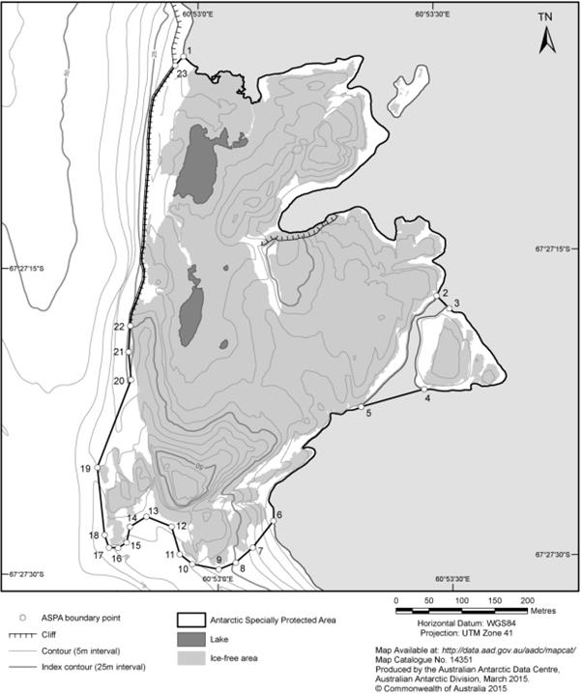
- Alt text:
Map showing Antarctic Specially Protected Area Number 101. Australian Antarctic Data Centre Map Catalogue Number 14351

Example 2
- This flowchart appears in section 58 of the Wine Australia Regulations 2018.
This Part sets out the procedure for including geographical indications that relate to foreign countries on the Register of Protected Geographical Indications and Other Terms. Translations of foreign geographical indications can also be included on the Register.
The procedure is as follows:
- Alt text:
Flowchart summarising the procedure for including geographical indications that relate to foreign countries (and translations of foreign geographical indications) on the Register of Protected Geographical Indications and Other Terms

Example 3
- This graph appears in subsection 392-5(1) of the Income Tax Assessment Act 1997.
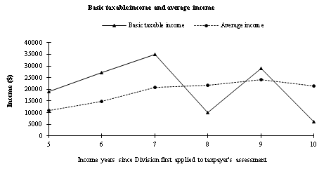
- Alt text:
A graph illustrating basic taxable income and average income
Example 4
- This logo appears in Schedule 2 to the Advance Australia Logo Protection Act 1984.
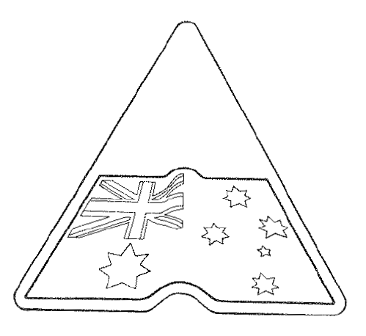
- Alt text:
A triangle with an Australian flag inside it and a ripple as though the flag is fluttering

Example 5
- This photo appears in Schedule 1 to the Tobacco Advertising Prohibition Regulation 1993.

Item | Health warning message | Corresponding graphic
1 | SMOKING HARMS UNBORN BABIES | 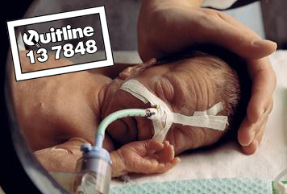

- Alt text:
Photograph of baby, laying down with eyes closed and medical tubes attached to the baby's nose. Baby's head is cupped by an adult hand. The word Quitline and the number 13 7848 appear in the top left-hand corner of the photograph

Example 6
- This image appears in Schedule 1 to the Australian Veteran’s Recognition (Putting Veterans and their Families First) Act 2019.
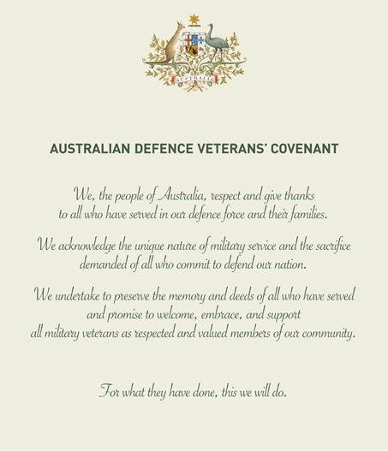
- Alt text:
The Australian Defence Veterans' Covenant. A text version could in 2021 be viewed on the Department of Veterans' Affairs' website (https://www.dva.gov.au/)

